**A network of disorders and disease genes**

* **Dataset:  *Diseasome* *(****Network with 1419 vertices and 3926 edges.****)***
* **Background**

 The Diseasome represents a complex network of interconnected disorders and disease genes based on known gene-disease associations. This network reveals that many diseases share common genetic origins, as genes associated with similar disorders are likely to interact physically and show similar expression profiles. The study of such networks supports the existence of distinct disease-specific functional modules, which can be crucial for understanding the genetic basis of diseases and for developing targeted therapies.

* **Initial Visualization**

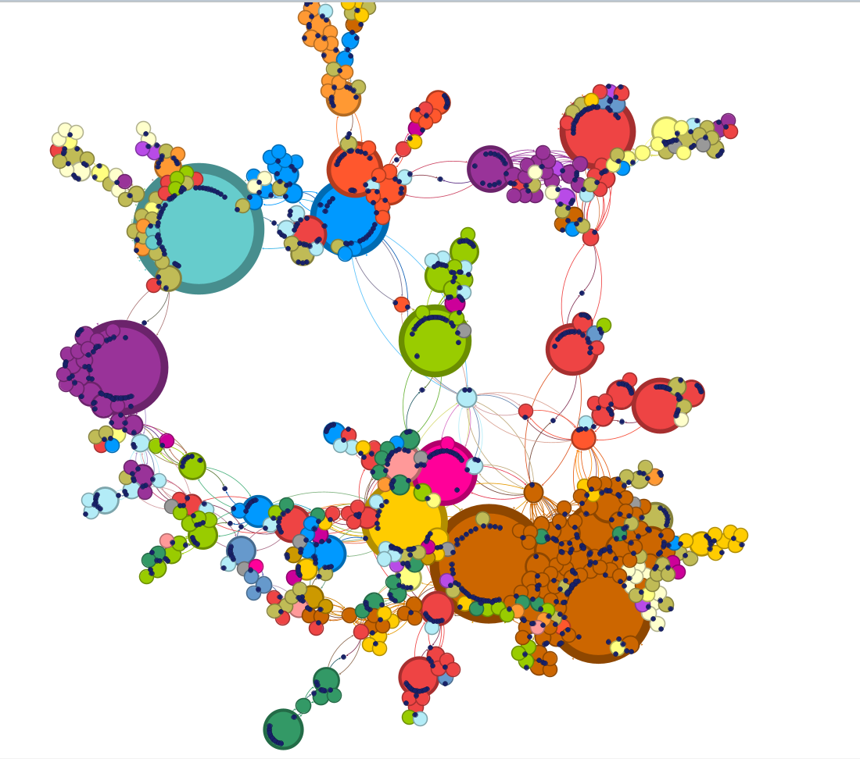

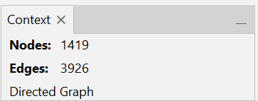

* **Layout Algorithms**
* **Force atlas**

The Force Atlas layout in Gephi is particularly effective for visualising the complex relationships between diseases and their associated genes. This layout spreads out the nodes (representing genes and diseases) by simulating a physical system where connected nodes attract each other, forming clusters that represent disease-specific functional modules. By applying Force Atlas, you can easily find groups of related diseases that share common genetic origins, making it easier to explore the genetic connections underlying various disorders.

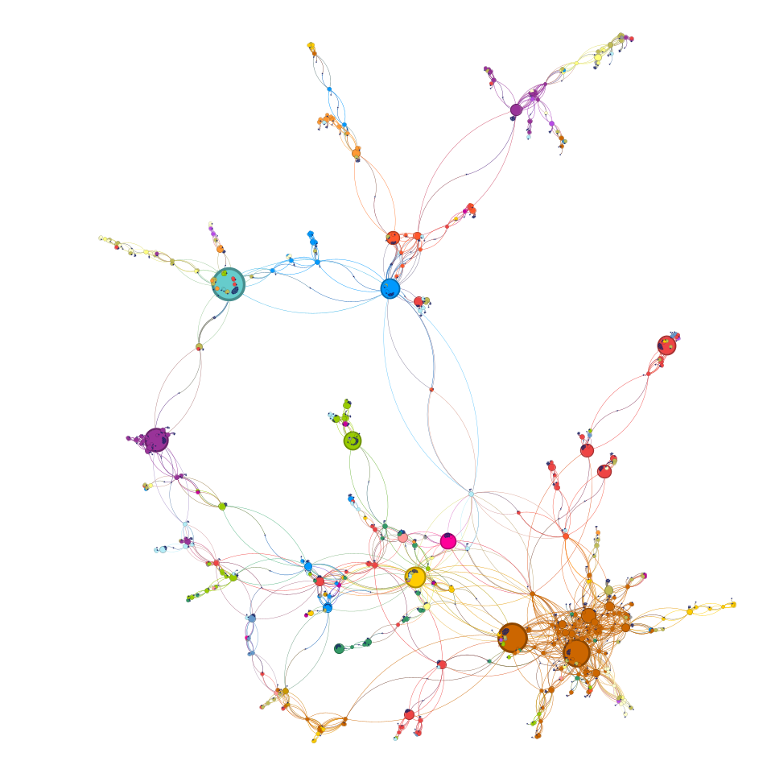

* **Label adjusts**

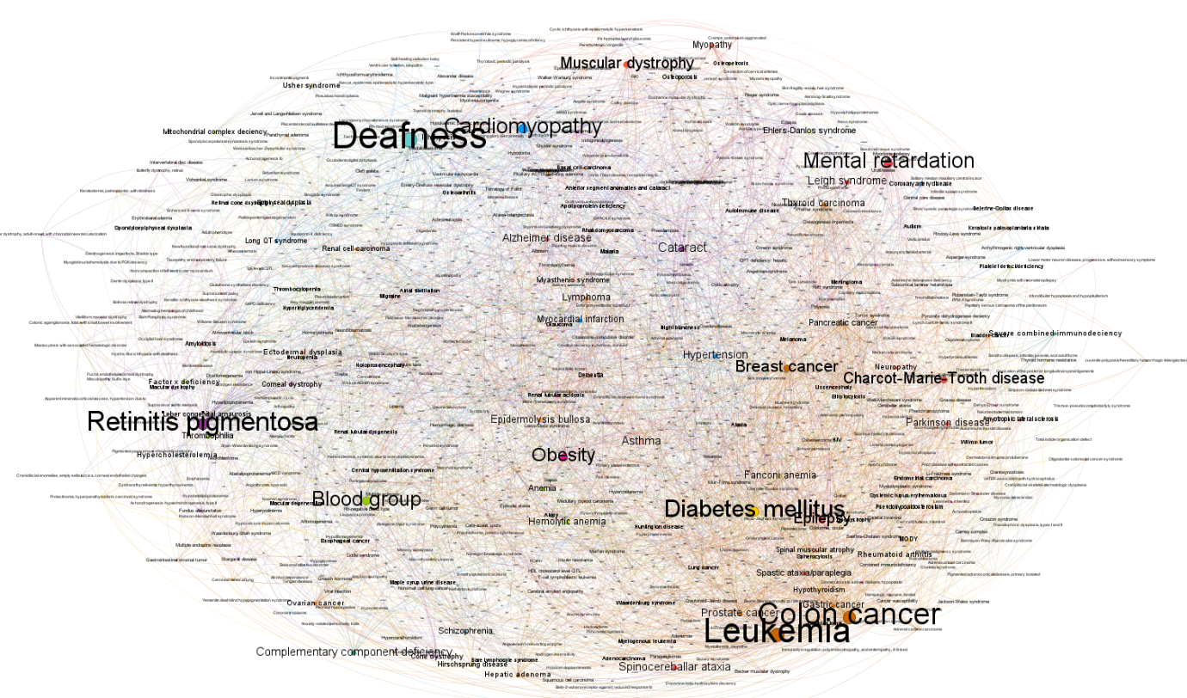In the Diseasome network, where genes and diseases are densely connected, the Label Adjust layout in Gephi helps ensure that all labels (representing gene and disease names) are visible and not overlapping. This layout automatically adjusts the position of labels to reduce clutter, making it easier to identify and interpret key genes and disease clusters in the network. By improving label readability, Label Adjust enhances the overall clarity of the network visualisation, allowing for a more accurate analysis of the genetic links between diseases.

* **Basic Statistics**
* **Data Laboratory**

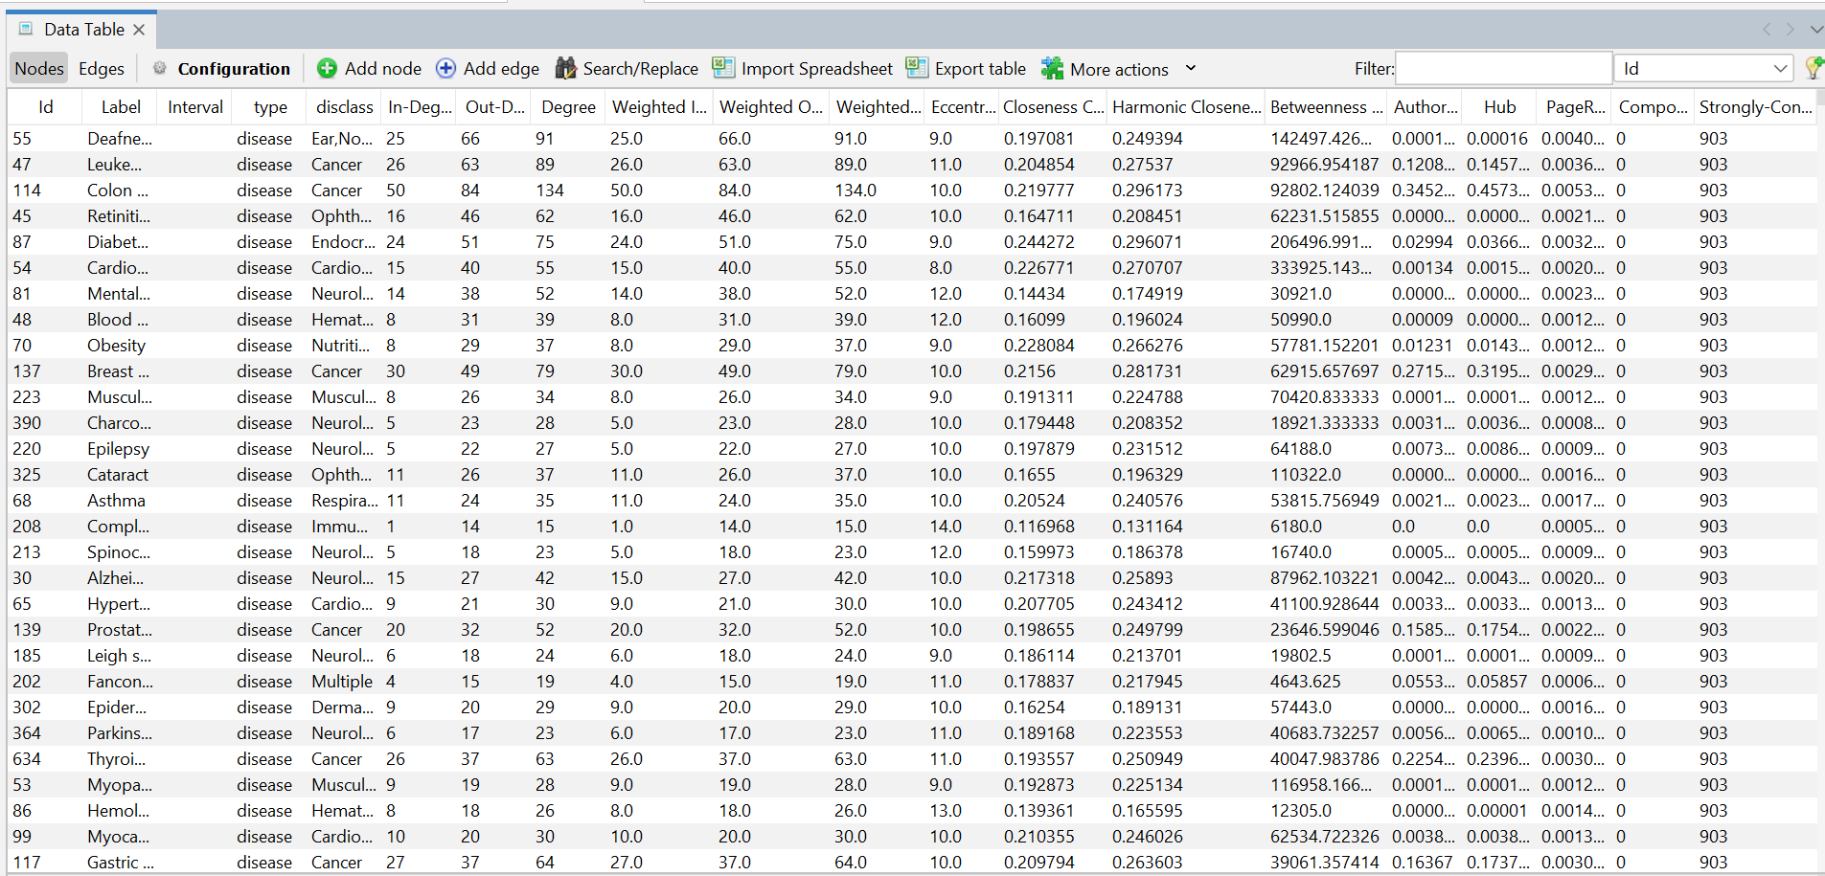

* **Average density**

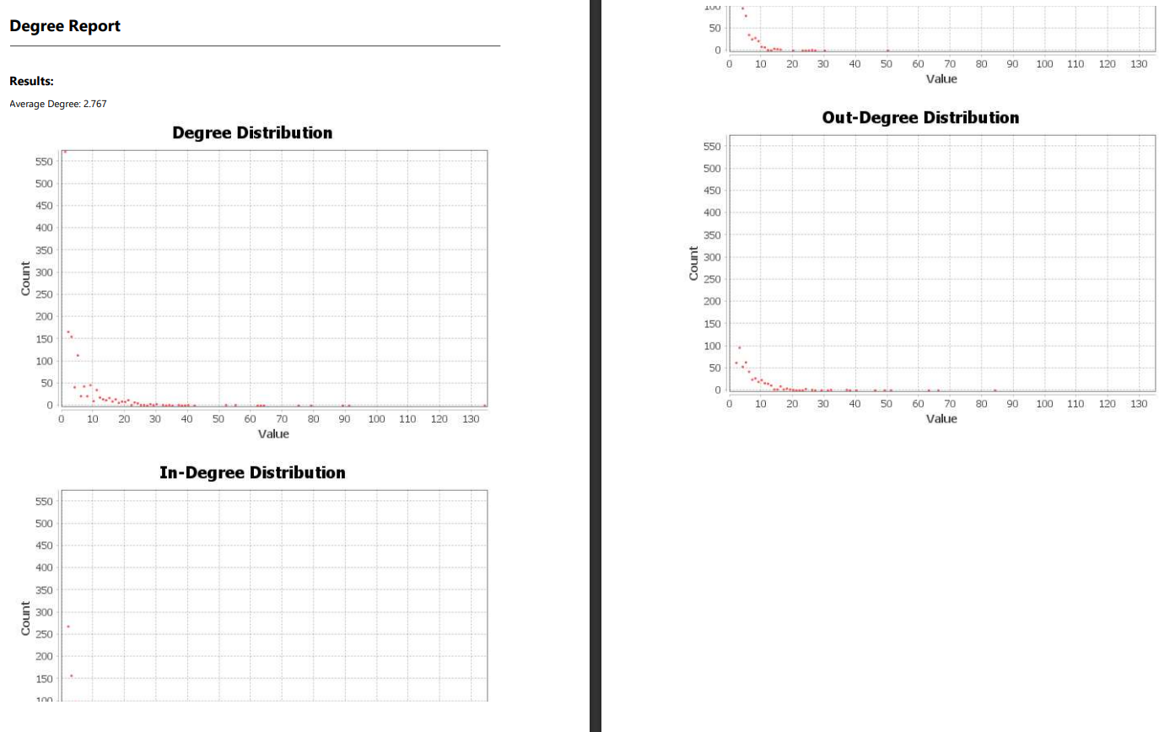

* + **Closeness centrality**

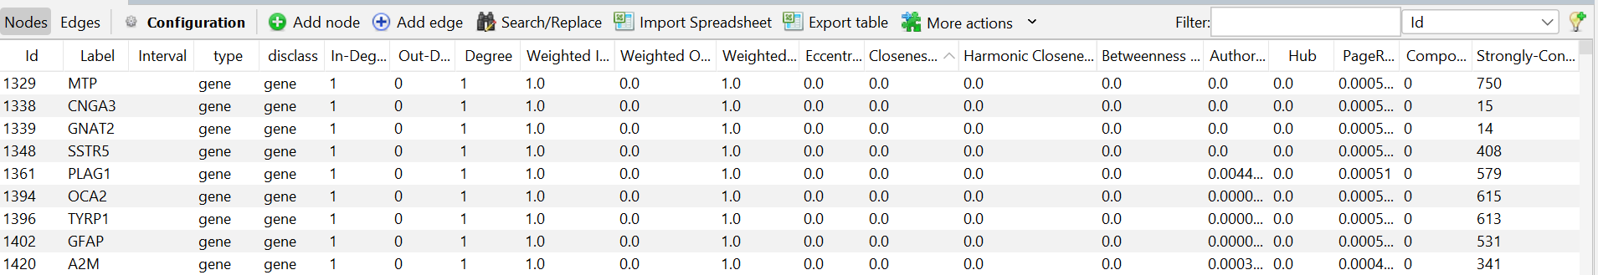

*Low to High*

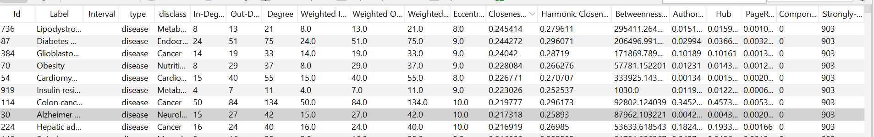

*High to Low*

* + 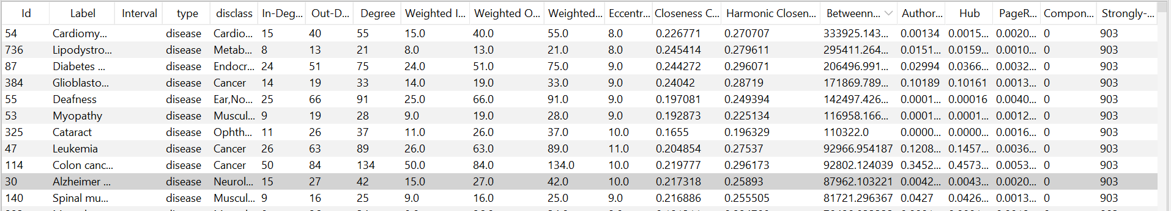**Betweenness centrality**

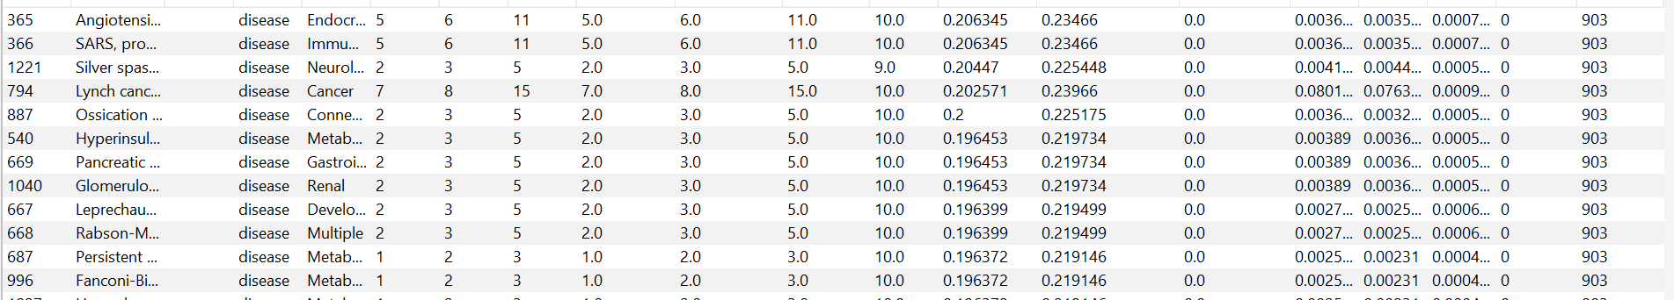

* + 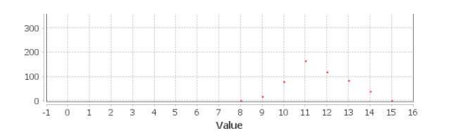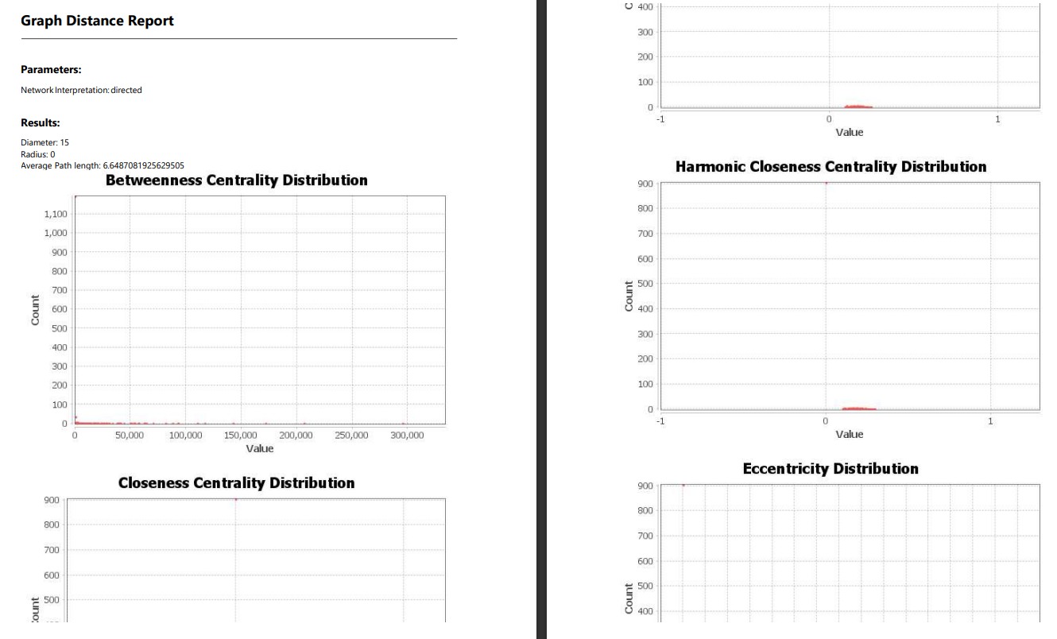**Based on degree**

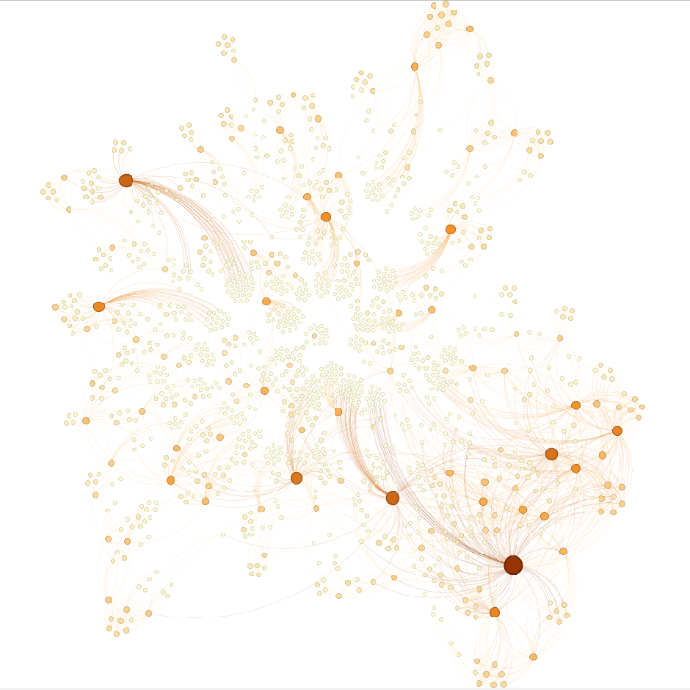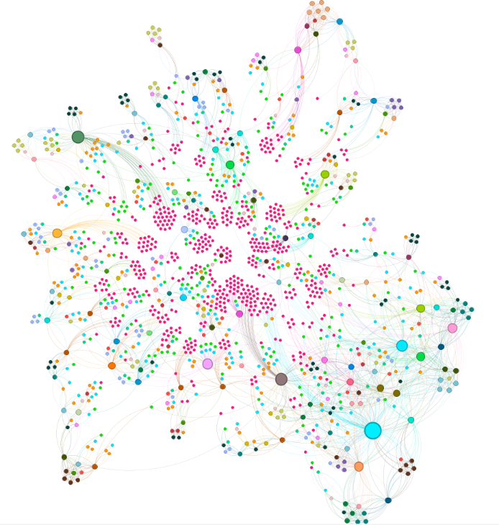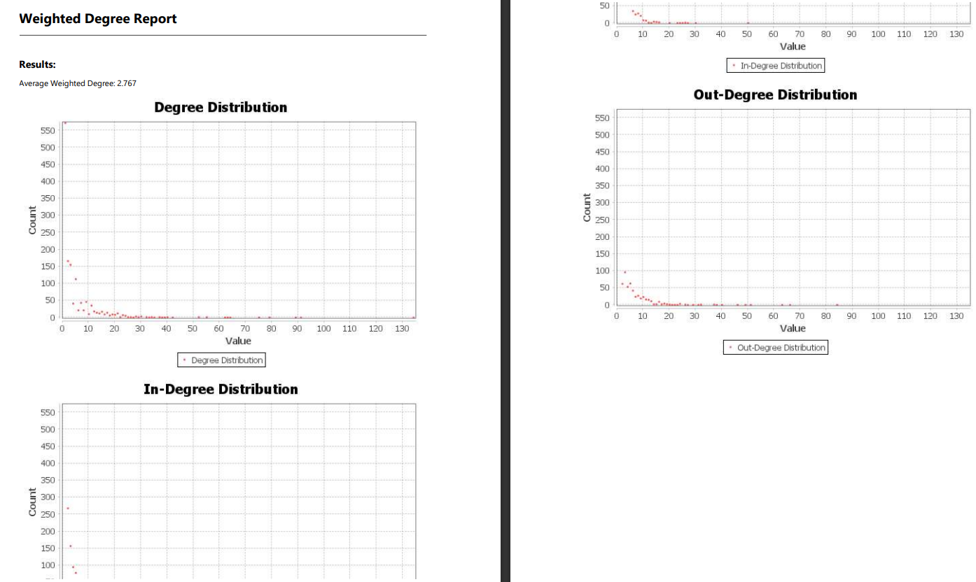

**1. Calculate Degree:**

* Go to the "Statistics" tab.
* Run the "Degree Distribution" algorithm to calculate the degree of each node.
* The degree values will be stored as a new attribute in the node table.

**2. Styling Nodes by Colour (Degree):**

* Switch to the "Overview" tab.
* In the "Appearance" panel, select the "Nodes" tab and click the colour palette icon.
* Choose "Attribute" from the drop-down, then select "Degree" as the attribute.
* Gephi will apply a colour gradient based on node degree.

**3. Styling Nodes by Size (Degree):**

* In the "Appearance" panel, select the "Size" icon under the "Nodes" tab.
* Choose "Attribute" and then select "Degree."
* Adjust the size range to reflect the degree values.
  + **Betweenness centrality**

**1. Calculate Centrality:**

* Go to the "Statistics" tab.
* Run the "Betweenness Centrality" algorithm to calculate the centrality of each node.
* The centrality values will be stored as a new attribute in the node table.

**2. Styling Nodes by Colour (Centrality):**

* Switch to the "Overview" tab.
* In the "Appearance" panel, select the "Nodes" tab and click the colour palette icon.
* Choose "Attribute" from the drop-down menu, then select "Betweenness Centrality" (or other centrality measures).
* Gephi will apply a colour gradient based on centrality values.

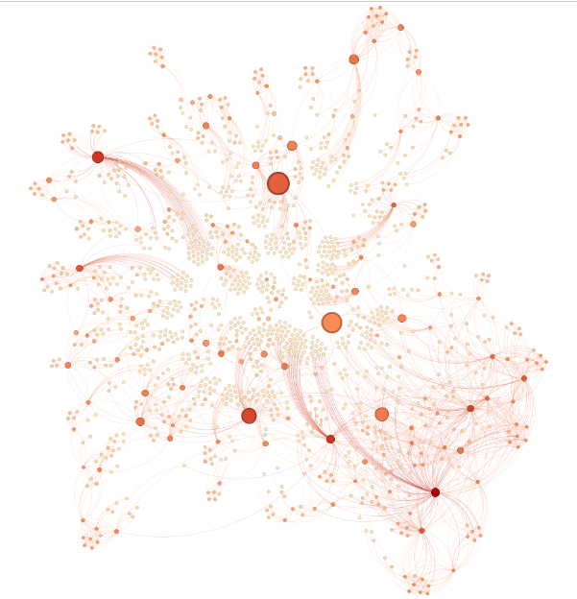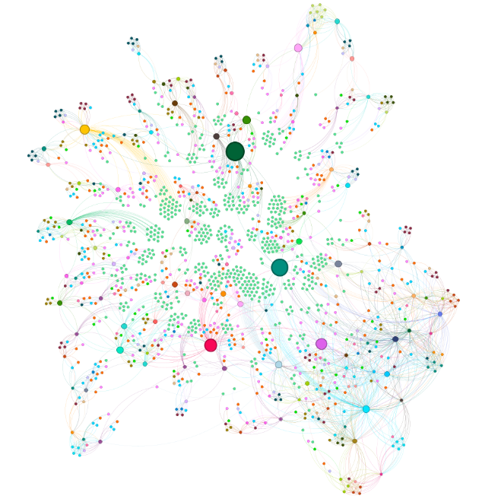

**3. Styling Nodes by Size (Centrality):**

* In the "Appearance" panel, select the "Size" icon under the "Nodes" tab.
* Choose "Attribute" and select "Betweenness Centrality."
* Adjust the size range to reflect the centrality values.

**4. Styling Edges by Colour:**

* If you want to style edges based on the centrality of connected nodes, select the "Edges" tab in the "Appearance" panel.
* **Community detection**

Community detection in the Diseasome network is a powerful method to show clusters of diseases and genes that are more intricately connected to each other than to the rest of the network. These clusters, or communities, often represent disease-specific functional modules, where genes within the same community are likely to share similar biological functions or pathways. By detecting and visualizing these communities in Gephi, you can uncover underlying patterns of genetic relationships, potentially revealing common genetic origins of related diseases and offering insights into their shared mechanisms.

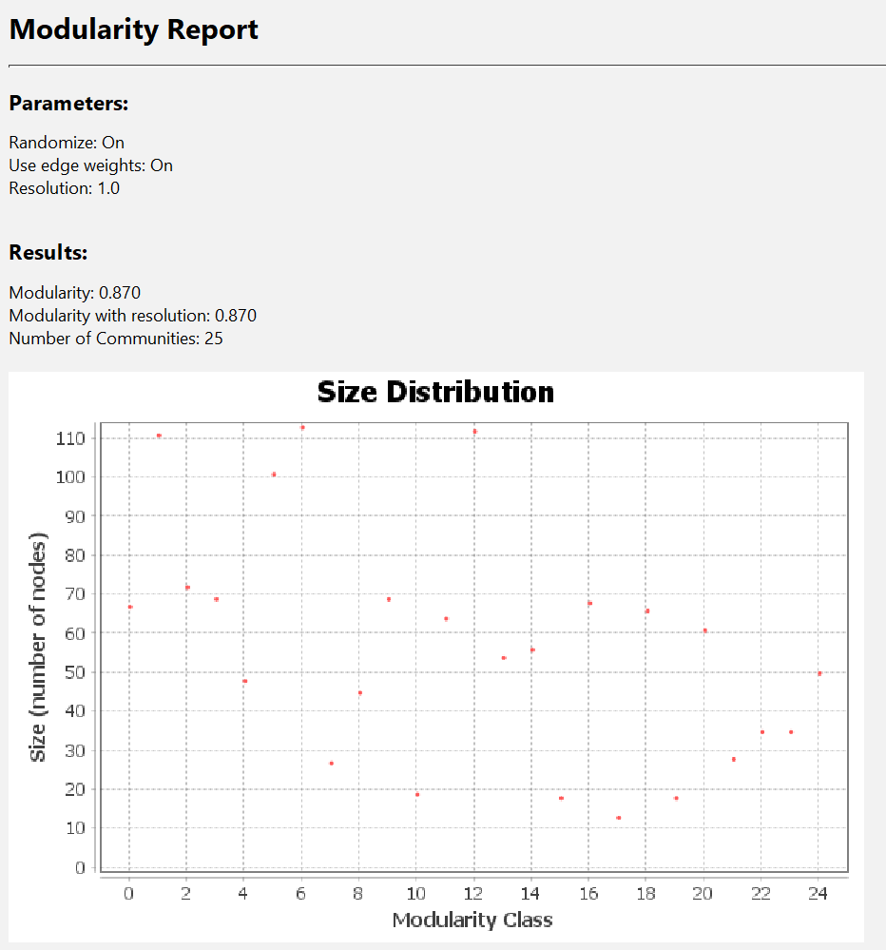

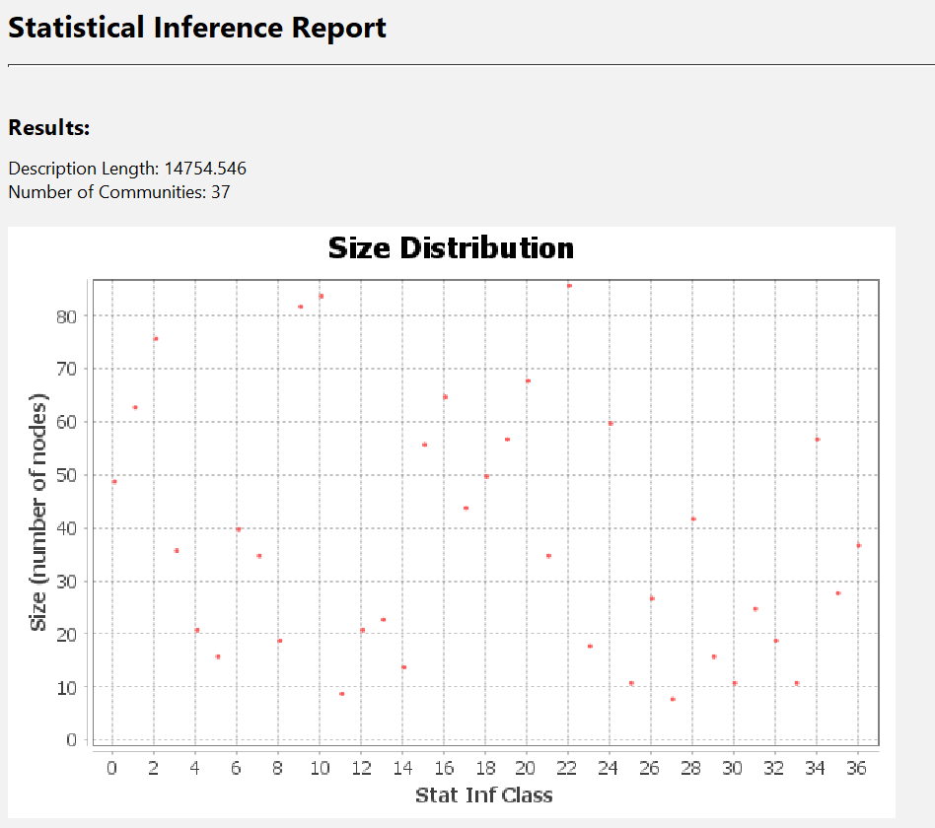

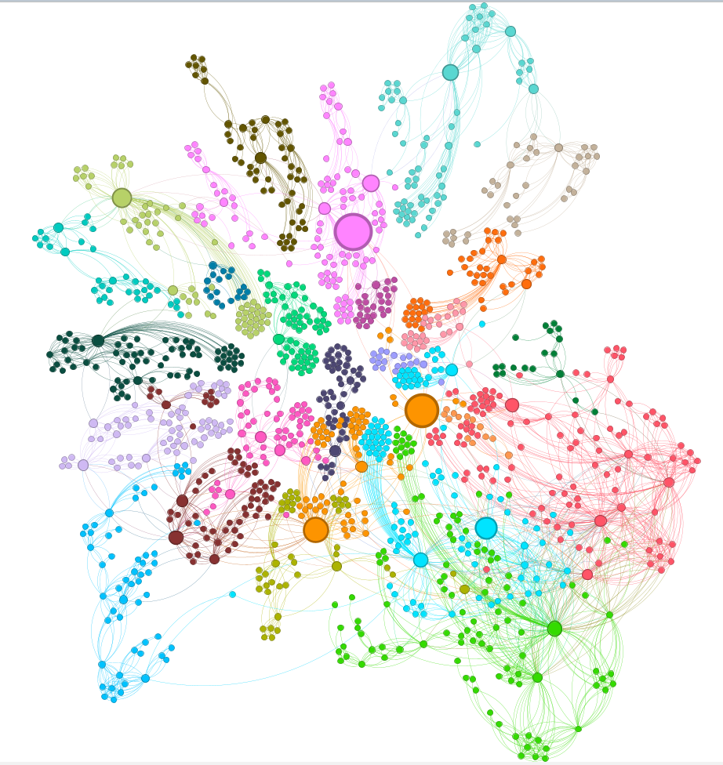

**1. Run the Community Detection Algorithm:**

* Go to the "Statistics" tab in Gephi.
* Select the "Modularity" algorithm, which is commonly used for community detection.
* Click "Run." The algorithm will compute and assign a modularity class (community) to each node based on their connectivity.

**2. Visualize Communities:**

* Switch to the "Overview" tab.
* In the "Appearance" panel, select the "Nodes" tab and click on the colour palette icon.
* Choose "Partition" and then select "Modularity Class" from the drop-down menu.
* Gephi will colour each node based on its community, with distinct colours representing different communities.

**3. Adjust Node and Edge Appearance:**

* You can further adjust node size based on degree or centrality within each community to highlight important nodes.
* Edges can also be styled to differentiate connections within communities versus between communities.

**4. Analyse Community Structure:**

* Review the resulting visualization to show significant communities.
* Use the "Data Laboratory" to explore the nodes and their assigned communities.
* Optionally, apply filters to focus on specific communities or compare their structures**.**
* **Use Cases for In-Degree and Out-Degree Filtering**

**Identifying Highly Impacted Diseases (In-Degree Filtering):**

* Use Case: Apply in-degree filtering to identify diseases that are influenced by many different genes. Diseases with a high degree may have a complex genetic basis, making them candidates for further research into multi-gene contributions to disease mechanisms.

**Spotting Key Genes with Broad Influence (Out-Degree Filtering):**

* Use Case: Use out-degree filtering to focus on genes that are associated with multiple diseases. Genes with a high out-degree could be crucial in understanding common genetic origins and could serve as potential targets for therapeutic interventions across several related disorders.

**Exploring Disease Networks for Common Pathways:**

* Use Case: Combine in-degree and out-degree filtering to investigate disease clusters where certain genes play a pivotal role, potentially uncovering shared pathways or biological processes that link these diseases. This can help in understanding comorbidities and developing treatments that address multiple conditions simultaneously.

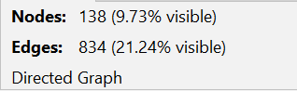**Degree above 15**

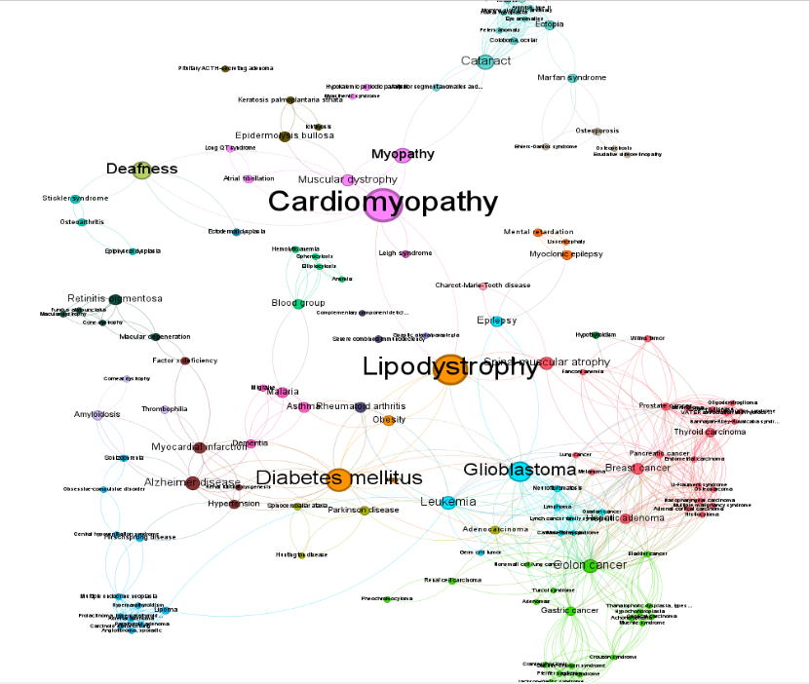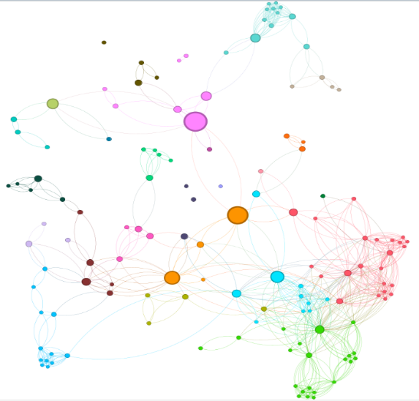

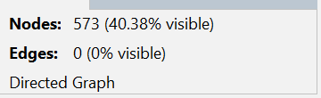**Degree of 1**

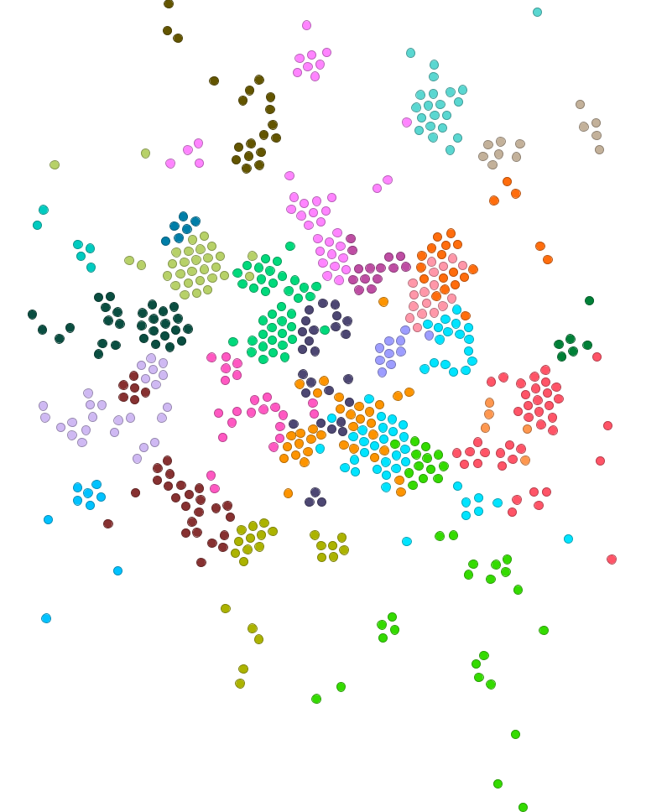

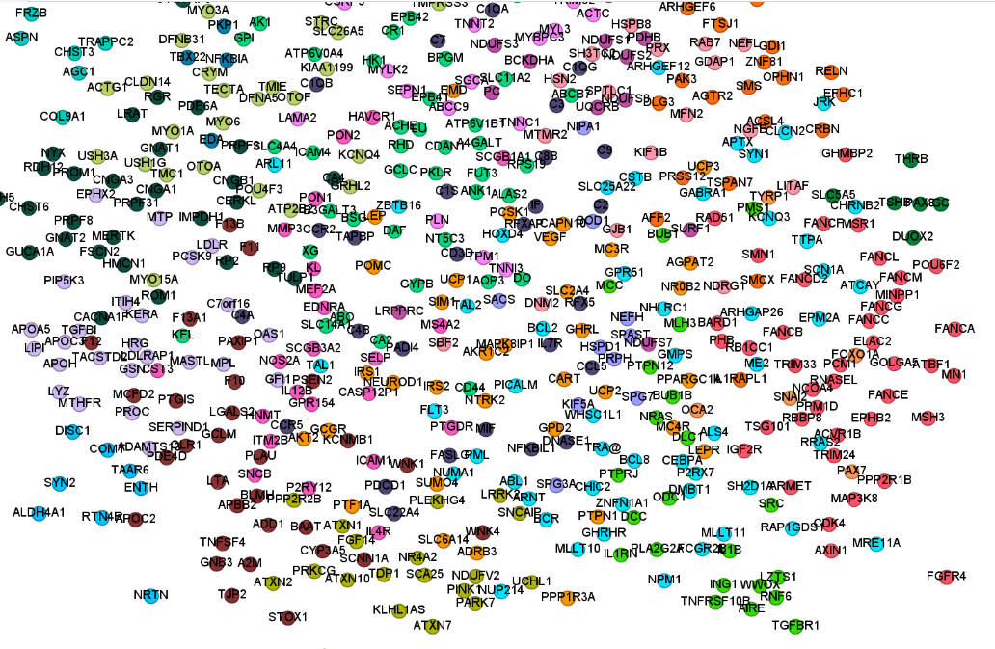

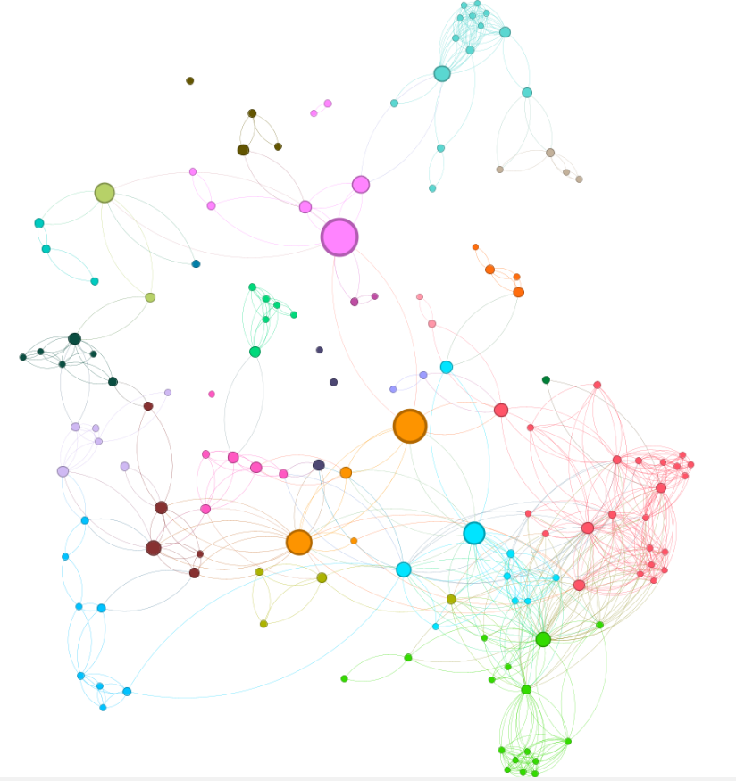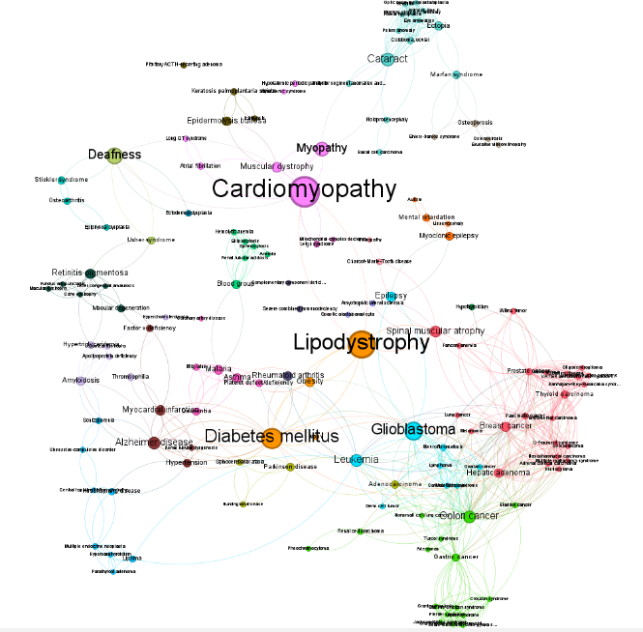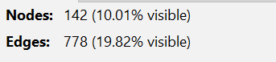**Out degree above 10**

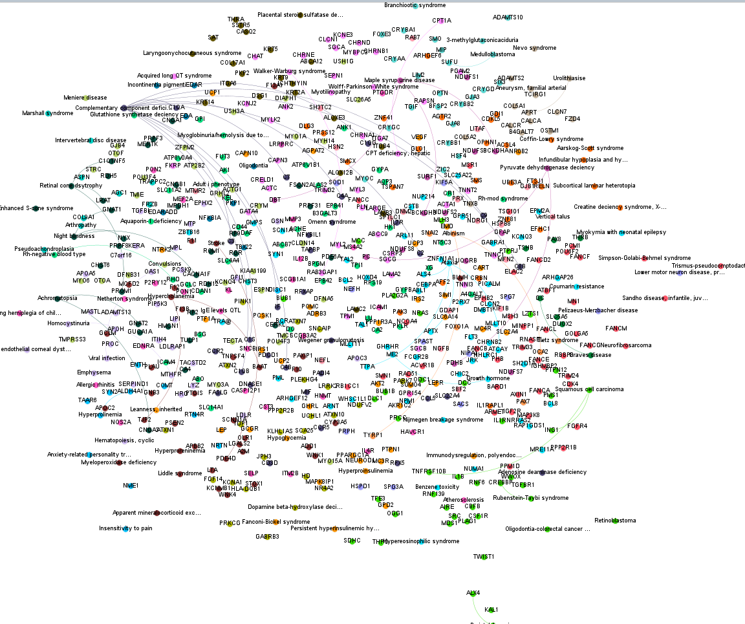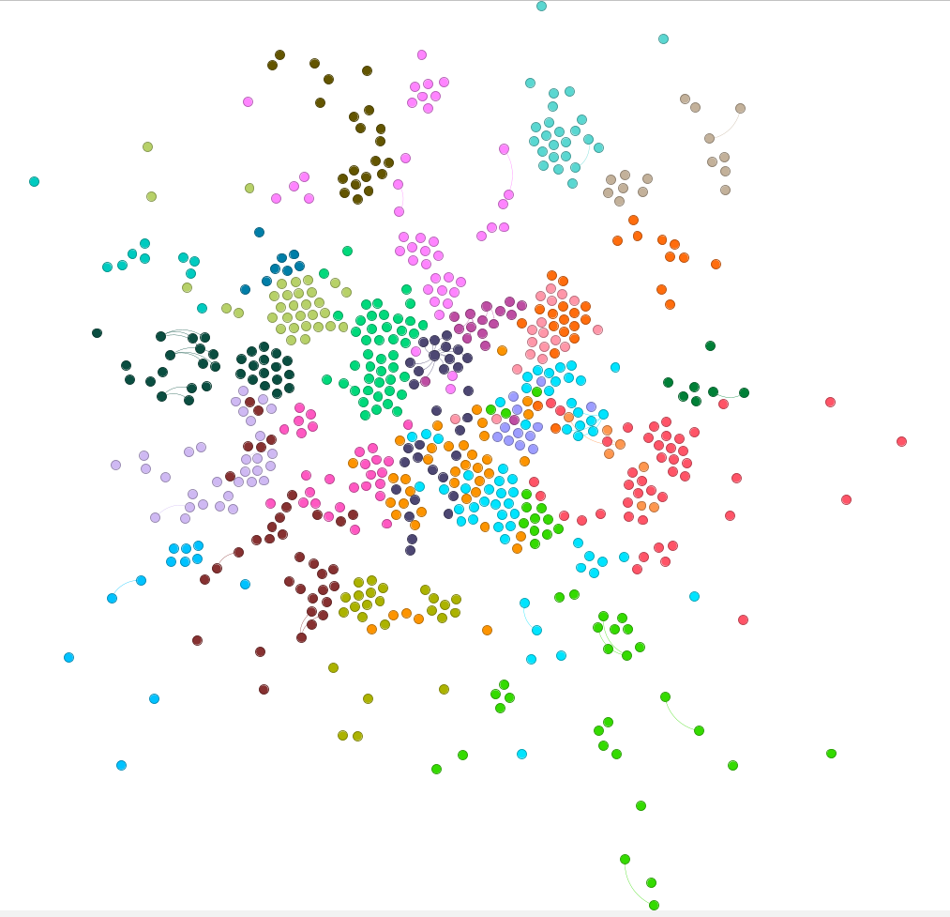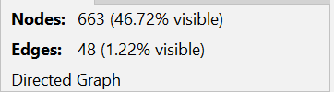**Indegree 1**

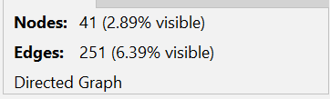**Indegree above 10**

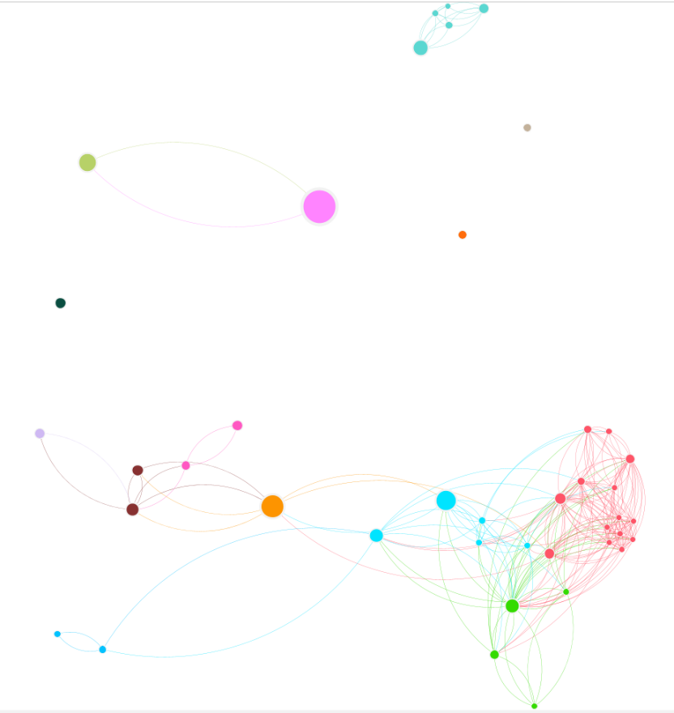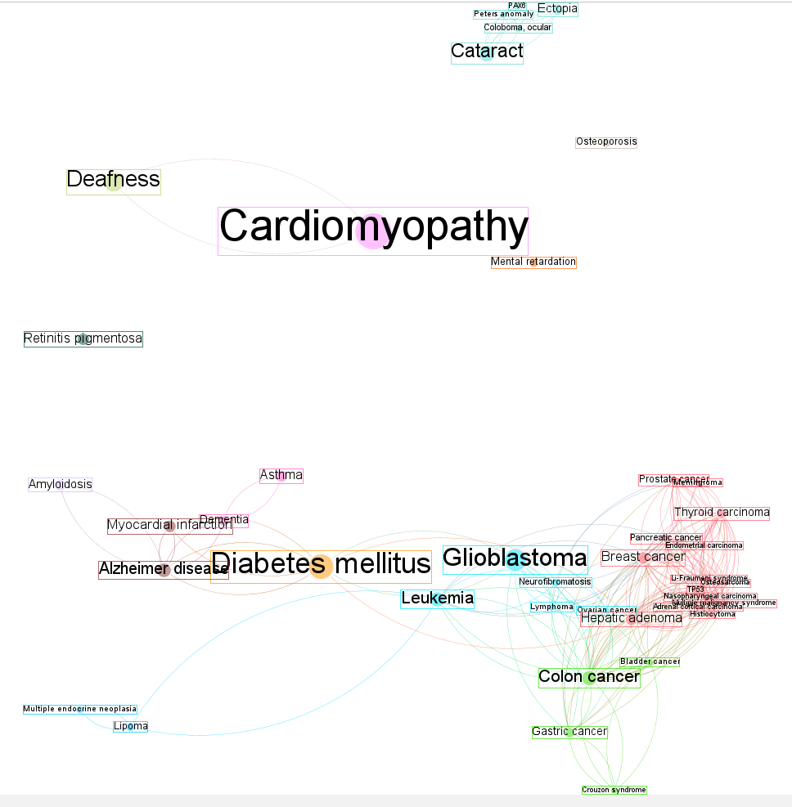

* **Eigenvector Centrality:**

Eigenvector centrality helps find influential genes and diseases by considering not just their direct connections but also the importance of their neighbours. This metric highlight node that are central within the network due to their connections with other key nodes, making it useful for pinpointing genes or diseases that play a crucial role in linking different disease communities. These central nodes are potential targets for further research or therapeutic development.

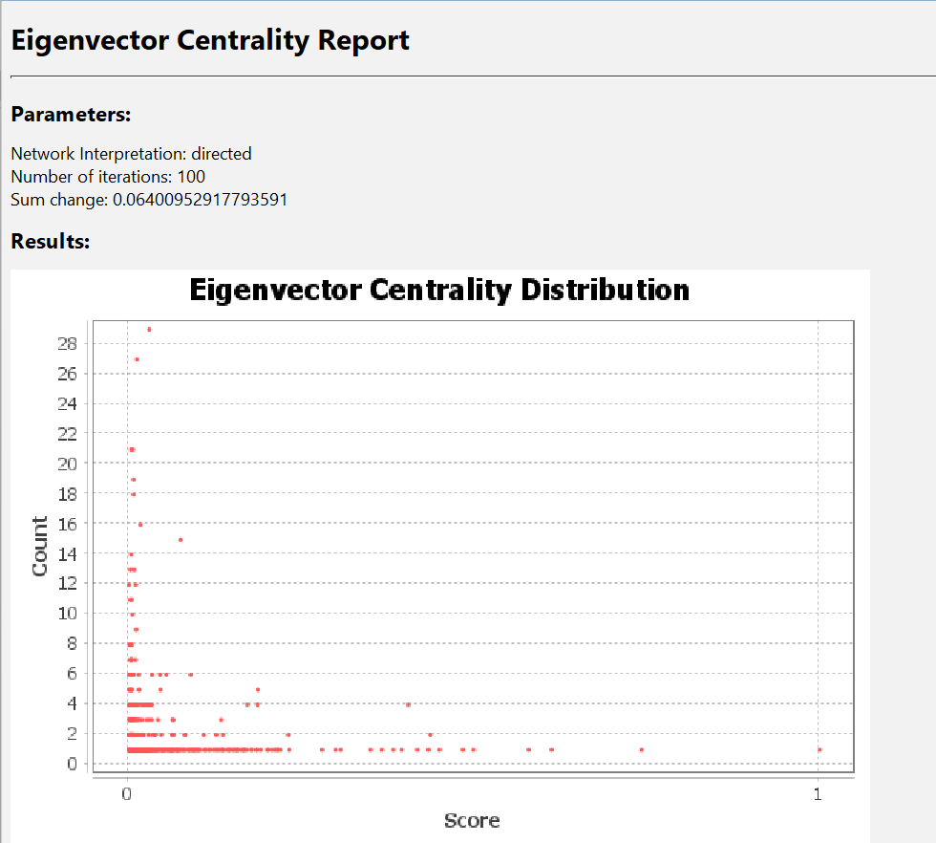

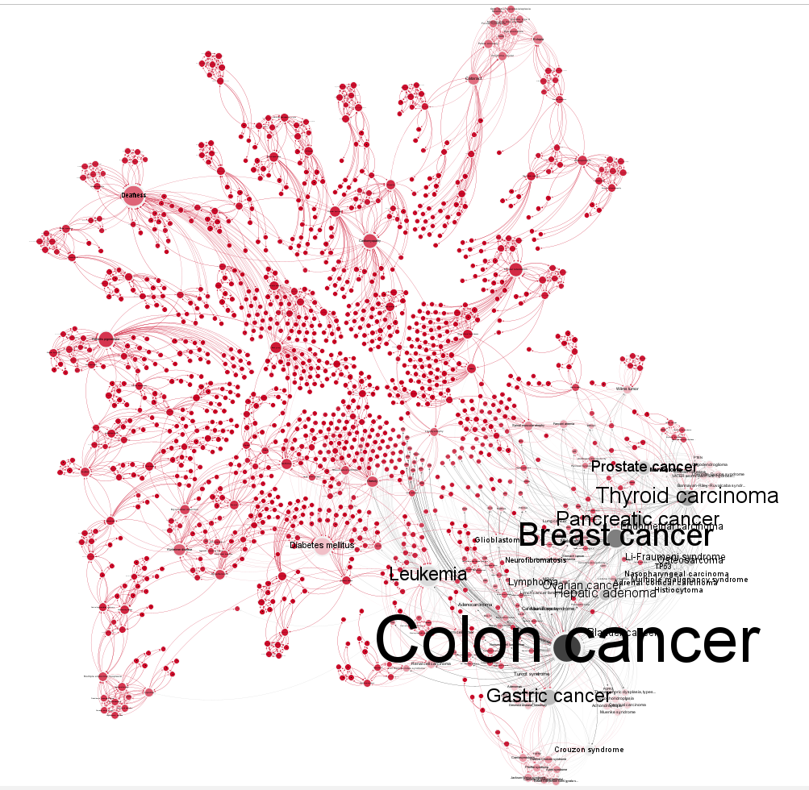

* **Subnetwork Analysis**

**Select Key Nodes:**

* Identify the nodes of interest that will serve as the focus for the subnetwork. This could be based on specific criteria such as high centrality, particular disease types, or genes of interest.

**Create an Ego Network (for central nodes):**

* **Select Node**: Click on the node you want to analyse to focus on its immediate network.
* **Apply the Ego Network Filter**:
  + Open the "Filters" panel.
  + Drag the "Ego Network" filter into the "Queries" workspace.
  + Adjust the "Radius" to include nodes within a specified distance from the central node.
  + Click "Apply" to generate the subnetwork around the selected node.

**Extract and Save the Subnetwork:**

* **Select Nodes and Edges:**
  + Use the "Selection" tool to manually select nodes and edges or apply filters to choose specific criteria.
* **Export or Create a New Graph:**
  + Right-click on the network view and select "Export Filtered" to save as a new file or "Create New Graph" to open a new workspace within Gephi.

**Visualize the Subnetwork:**

* Apply Layout Algorithm: Use "Force Atlas" to organize the nodes and edges for clarity.
* Customize Appearance: Adjust node sizes, colours, and edge styles to highlight key features and improve readability.

**Analyse the Subnetwork:**

* Run Metrics and Algorithms: Perform analyses such as centrality, community detection, or clustering within the subnetwork to uncover insights.
* Interpret Results: Examine the subnetwork’s structure and relationships to understand its significance.

